**Note on Dataset Availability**  
During the execution of **Task 1: Data Cleaning & Preprocessing**, I attempted to download all the datasets provided. However, two datasets could not be accessed due to source-related issues:

1. **NYC Taxi Trips** – The dataset link (“NYC Taxi Data 11”) was not reachable at the time of access, and therefore the data could not be retrieved.
2. **Retail Sales Data (train.csv)** – The dataset was not downloadable due to restrictions on the Link Provided.

I have attached screenshots of the attempts as evidence of this issue. In light of this, the cleaning and preprocessing steps were performed on the remaining accessible datasets. If required, I am prepared to substitute these with similar publicly available datasets to demonstrate the intended data cleaning techniques.

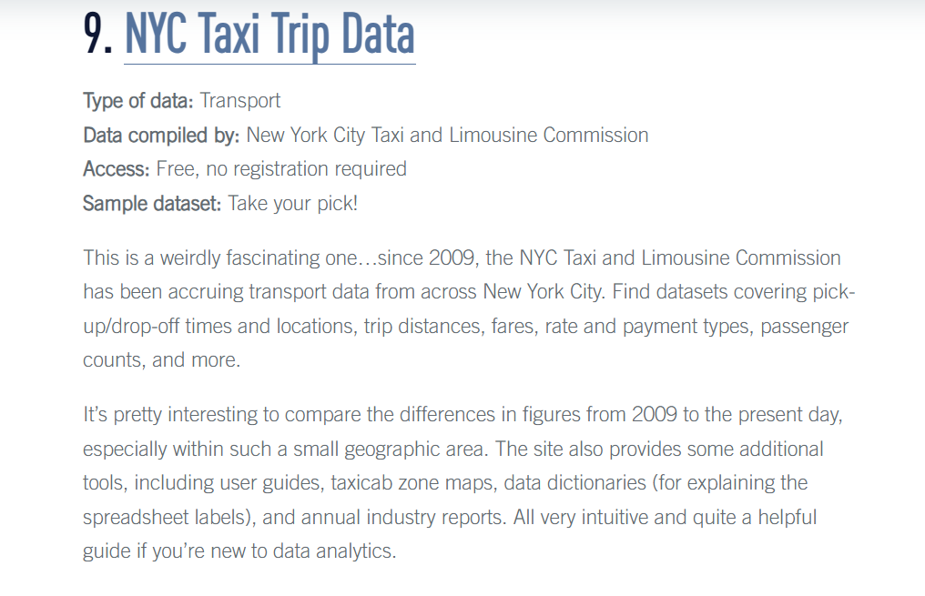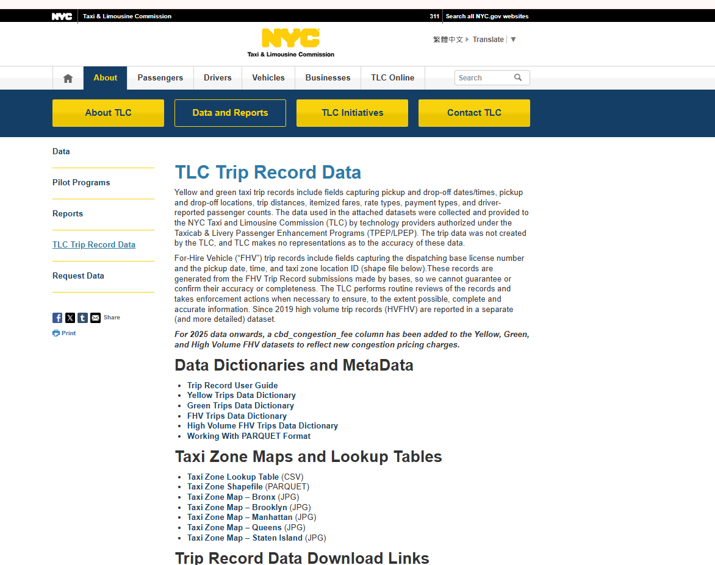

* There was no link or file to Download the Dataset mentioned in the Pdf

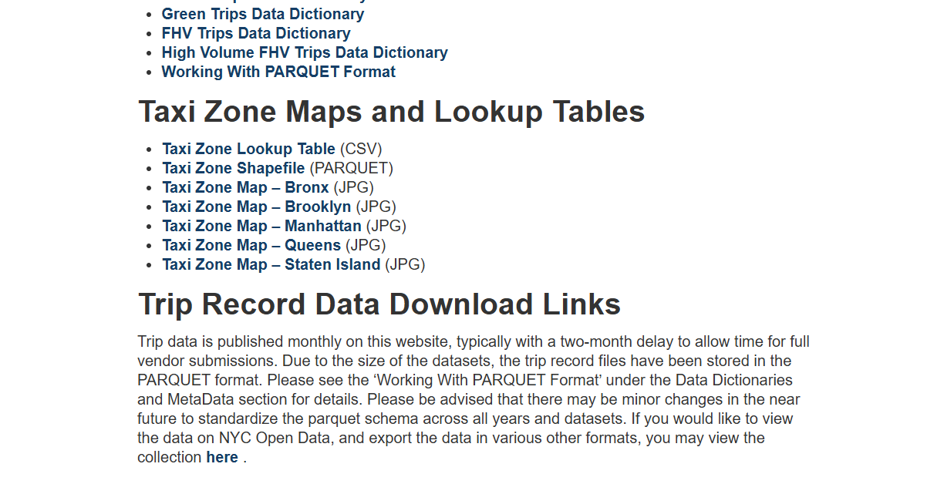

* For the Second on Clicking on the Retail sales Dataset Link I am taken to this page and not able to download the dataset

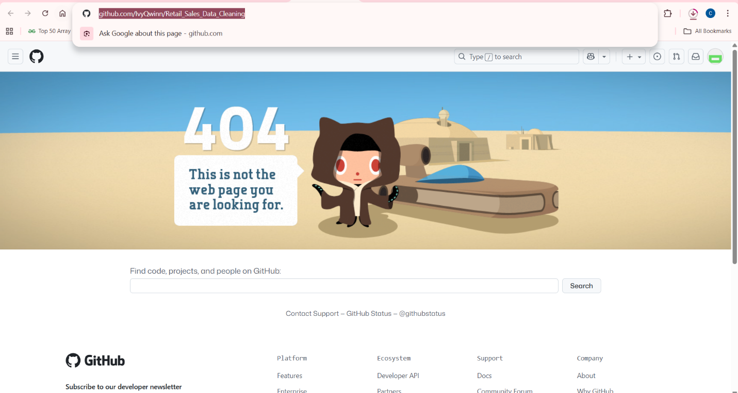

I have attached screenshots of the attempts as supporting evidence. I kindly request you to consider this situation and excuse me for the unavailability of these two datasets. For the remaining datasets, the complete data cleaning and preprocessing steps have been carried out as instructed.